Comparative Current Control of an Isolated OBC-Based Bidirectional V2V Charger Using PI, Integral Sliding-Mode and Fuzzy Logic Controllers with Real-Time Validation
N. Subramanian  School of Electrical Engineering  Vellore Institute of Technology  Chennai, India  subramanian.aadhi2006@gmail.com | Sahas Vishanth M. V.  School of Electrical Engineering  Vellore Institute of Technology  Chennai, India  sahasvishanthmv@gmail.com | Tanukasree R.  School of Electrical Engineering  Vellore Institute of Technology  Chennai, India  sreetanuka0628@gmail.com | G. Kanimozhi  School of Electrical Engineering  Vellore Institute of Technology  Chennai, India  email address

Abstract—Vehicle-to-vehicle (V2V) charging lets an electric vehicle (EV) with surplus energy charge another EV without fixed infrastructure. This paper evaluates closed-loop charging-current control of an isolated single-stage bidirectional V2V converter that reuses the onboard charger (OBC) bridges of both vehicles and couples them through an external series-resonant connector with a 1:1 high-frequency transformer. The converter, rated at 24 kW between a 350 V and a 450 V battery, is modelled in MATLAB/Simulink, and its voltage gain and duty-ratio operating points are identified in open loop for both power-flow directions. Proportional–integral (PI), integral sliding-mode (ISMC) and Mamdani fuzzy logic (FLC) current controllers are then designed and compared under a stepped 10–50 A constant-current reference. ISMC and FLC settle faster and with smaller deviations than PI. FLC attains the highest efficiency, about 94–95%, for EV2-to-EV1 transfer, while PI is the most efficient (89–93%) for EV1-to-EV2 transfer. Datasheet-based semiconductor loss estimates and software-in-the-loop validation on an OPAL-RT OP4610XG real-time simulator confirm bidirectional operation with all three controllers.
Index Terms—Bidirectional DC–DC converter, electric vehicle, fuzzy logic control, integral sliding mode control, onboard charger, OPAL-RT, vehicle-to-vehicle (V2V) charging
I. Introduction
Electric vehicle (EV) adoption is growing faster than public charging infrastructure, and a vehicle with a depleted battery in a remote location or an emergency may have no charger within reach [1], [2]. Vehicle-to-vehicle (V2V) charging addresses this by transferring energy directly from one EV battery to another, using the bidirectional power-flow capability that is increasingly available in onboard chargers (OBCs).
Several V2V architectures have been reported. Shafiqurrahman et al. [3] connect the DC links of two vehicles through their existing on-board converters, which avoids extra hardware but provides no galvanic isolation between the batteries. Taghizadeh et al. [4] add V2V assistance to a single-phase OBC, at the cost of a multistage conversion chain with an efficiency of about 87%. Ucer et al. [5] compare interleaved bidirectional buck–boost V2V chargers for 250–800 V batteries, again without isolation, and integrated converters that share drive-train or charger hardware across G2V, V2G and V2V modes have also been proposed [6], [7].
Galvanic isolation is normally obtained with high-frequency-transformer (HFT) converters such as the dual active bridge [8], [9] or resonant CLLC/LLC converters [10], which add a dedicated isolated stage. Zhou et al. [11] recently proposed an isolated connector for direct V2V charging in which the OBC bridges of both vehicles are reconfigured into a single-stage converter, with a series-resonant tank and a 1:1 HFT placed in an external connector. This topology provides isolation and voltage matching in one stage, and its charging current was regulated with a PI controller.
Nonlinear and intelligent controllers have been applied to improve the dynamics of isolated bidirectional converters. Sun et al. [12] combine adaptive integral sliding-mode control with a radial-basis-function network for a dual active bridge (DAB) and obtain better robustness and transient response than nonintegral sliding-mode control. Shivakumar et al. [13] show that fuzzy logic control regulates the DC voltage of an EV DAB converter better than PI control, and Chitra Devi et al. [14] optimize a fuzzy controller for a bidirectional DC–DC converter with the Fire Hawk search algorithm. However, their performance on the OBC-based isolated V2V converter, where the same hardware must regulate current in both directions with different gate-signal mappings, has not been evaluated. This paper makes the following contributions:
- a model and gain analysis of the isolated OBC-based V2V converter of [11] for 350 V/450 V batteries, with open-loop identification of the operating duty ratios in both directions;
- the design of PI, integral sliding-mode (ISMC) and fuzzy logic (FLC) current controllers that share a common mode-selection and gate-signal structure;
- a comparison of the three controllers in transient response, efficiency and semiconductor losses; and
- software-in-the-loop (SIL) validation of all three controllers on an OPAL-RT OP4610XG real-time simulator.
Section II describes the converter, Section III its design, Section IV the controllers, Section V the results, and Section VI concludes the paper.

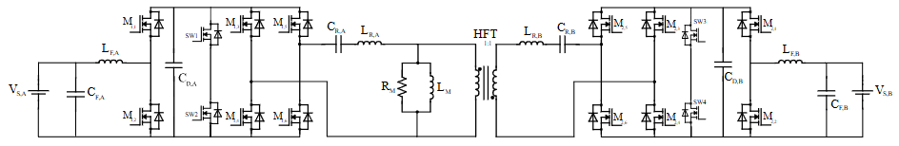
Fig. 1. Isolated single-stage bidirectional V2V converter formed by the reconfigured OBC bridges of EV1 (left) and EV2 (right) and the external resonant HFT connector (topology from [11]).
II. Converter Topology and Operation
Fig. 1 shows the converter. In each vehicle, the leg M_{x,1}–M_{x,2} of the three-phase OBC bridge, together with the battery-side filter L_{F}, C_{F} and the DC-link capacitor C_{D}, forms a boost/buck stage that sets the voltage gain. The remaining legs M_{x,3}–M_{x,6} form a high-frequency H-bridge that excites the connector, with M_{x,5} held on and M_{x,6} held off. The connector contains a series-resonant tank on each side, formed by C_{R} and the transformer leakage inductance L_{R}, and a 1:1 HFT whose magnetizing inductance L_{M} and core-loss resistance R_{M} are included in the model. Together, the battery, filter and bridge of each vehicle act as an equivalent isolated Ćuk converter, so voltage regulation and galvanic isolation are achieved in a single stage.
Both power-flow directions use the same hardware and differ only in how a PWM signal of duty ratio D and its complement (NPWM) are assigned to the switches (Table I). In Mode 1 (EV1 charging EV2), L_{F,A} stores energy through M_{1,2} during the PWM interval while C_{R,A} discharges into the HFT. During the NPWM interval, L_{F,A} releases its energy together with the source into the DC link and recharges the resonant tank, and the receiving bridge delivers the transferred energy to battery B through L_{F,B}. Mode 2 (EV2 charging EV1) is obtained by exchanging the PWM and NPWM assignments. Fig. 2 shows the resulting Mode 1 waveforms: the filter-inductor currents are triangular and the transformer windings carry bipolar square-wave voltages.

TABLE I
GATE-SIGNAL ASSIGNMENT FOR BOTH POWER-FLOW DIRECTIONS
Signal | Mode 1 (EV1 → EV2) | Mode 2 (EV2 → EV1)
PWM (D) | M_{1,2}, M_{1,3}, M_{2,1}, M_{2,4} | M_{1,1}, M_{1,4}, M_{2,2}, M_{2,3}
NPWM (1 − D) | M_{1,1}, M_{1,4}, M_{2,2}, M_{2,3} | M_{1,2}, M_{1,3}, M_{2,1}, M_{2,4}
Constant 1 | M_{1,5}, M_{2,5} | M_{1,5}, M_{2,5}
Constant 0 | M_{1,6}, M_{2,6} | M_{1,6}, M_{2,6}

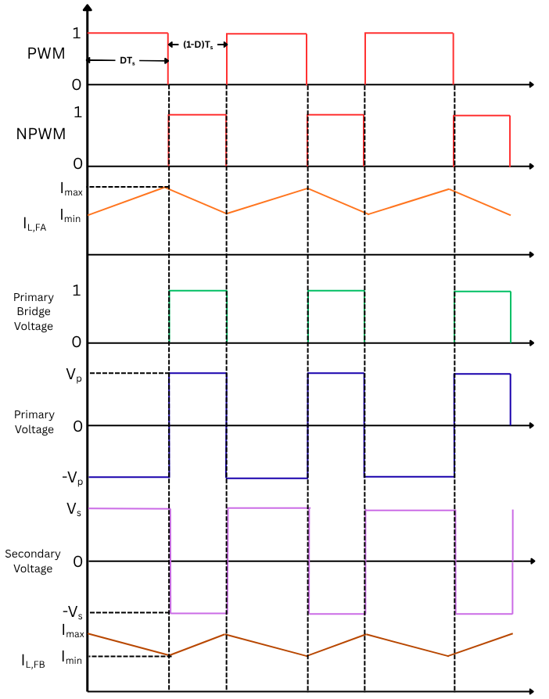
Fig. 2. Theoretical waveforms in Mode 1 (EV1 charging EV2): PWM/NPWM gate signals, filter-inductor currents and transformer primary and secondary voltages.
Because the HFT ratio is 1:1 and the resonant tank has near-unity gain at resonance, the DC-link voltage is transferred across the connector unchanged. Applying volt–second balance to L_{F,A} and L_{F,B} over one switching period gives
$V_{S,A} − v_{CD,A} = \left(1 − D\right)\left(v_{CR,A} + v_{1}\right)$ (1)
$v_{CD,B} − V_{S,B} = \left(1 − D\right)v_{CR,B}$ (2)
which combine into the Ćuk-type voltage gain of Mode 1,
$\frac{V_{S,B}}{V_{S,A}} = \frac{D}{1 − D}$ (3.1)
In Mode 2, exchanging PWM and NPWM gives
$\frac{V_{S,A}}{V_{S,B}} = \frac{1 - D}{D}$ (3.2)
III. Converter Design
The converter links a 350 V, 60 Ah battery (EV1) and a 450 V, 80 Ah battery (EV2) at a rated power of 24 kW. The battery-side filters are sized for 5% current ripple at D = 0.57 using
$L_{F} = \frac{V_{L}D}{ΔI_{L}f_{S}}, C_{F} = \frac{ΔI}{8f_{S}ΔV}$ (4)
For EV1 (I_{L} = 63.5 A, V_{L} = 350 V) this gives L_{F,A} = 3.14 mH, and C_{F,A} = 2 µF limits the voltage ripple to about 3%. For EV2 (52.9 A, 450 V), L_{F,B} = 4.8 mH and C_{F,B} = 1.3 µF give the same ripple. The resonant tank on each side sets the resonant frequency
$f_{R} = \frac{1}{2π\sqrt{L_{R}C_{R}}}$ (5)
around which soft switching is obtained. Table II lists the design values.
TABLE II
CONVERTER SPECIFICATIONS AND DESIGN PARAMETERS
Parameter | Value
EV1 battery (nominal voltage, capacity) | 350 V, 60 Ah
EV2 battery (nominal voltage, capacity) | 450 V, 80 Ah
Rated power | 24 kW
Filter inductance L_{F,A} / L_{F,B} | 3.14 mH / 4.8 mH
Filter capacitance C_{F,A} / C_{F,B} | 2 µF / 1.3 µF
DC-link capacitance C_{D,A} / C_{D,B} | 0.5 mF / 0.8 mF
Resonant capacitance C_{R} (each side) | 0.21 mF
Resonant (leakage) inductance L_{R} (each side) | 0.3015 µH
HFT turns ratio | 1:1
Switching frequency f_{S} | 20 kHz
Power switches | IKWH75N65EH7 IGBT [15]

IV. Controller Design
All three controllers regulate the battery charging current I_{meas} to a reference I_{ref} and share the structure of Fig. 3. A mode-selection block chooses the feedback current and gate mapping from the power-flow direction. The controller output is limited to a valid duty ratio, compared with a triangular carrier to produce PWM, and complemented to give NPWM. The tracking error is e = I_{ref} − I_{meas}.
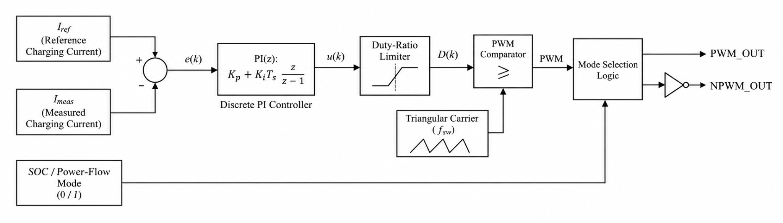Fig. 3. Common current-control structure (shown with the discrete PI controller); the ISMC and FLC laws replace the PI block.
A. PI Controller
The discrete PI controller implements
$u\left(t\right) = K_{p}e\left(t\right) + K_{i}\int_{0}^{t}{}e\left(τ\right)dτ$ (6)
with gains tuned by the Ziegler–Nichols method to K_{p} = 0.0001 and K_{i} = 0.015. It is the baseline controller of [11].
B. Integral Sliding-Mode Controller
The ISMC uses the integral sliding surface and boundary-layer control law
$s\left(t\right) = e\left(t\right) + λ\int_{0}^{t}{}e\left(τ\right)dτ$ (7)
$D_{cmd} = D_{0} + k sat\left(\frac{s}{φ}\right)$ (8)
where D₀ is the nominal duty ratio and φ the boundary-layer width. The saturation function replaces the discontinuous sign function to limit chattering. The parameters λ = 2, φ = 0.5, k = 0.005 and D₀ = 0.5 were selected by simulation.
C. Fuzzy Logic Controller
The Mamdani FLC takes the normalized error e(k) and its change Δe(k) = e(k) − e(k − 1), each on [−1, 1] with five triangular membership functions (NB, NS, Z, PS, PB). The output on [0, 1] has three triangular membership functions, Low [0.30, 0.40, 0.50], Medium [0.45, 0.50, 0.55] and High [0.50, 0.60, 0.70], which keep the command near the nominal duty ratio. The 25 rules of Table IV are evaluated with min–max inference, and the crisp command is obtained by centroid defuzzification:
$u^{*} = \frac{\int_{0}^{1}{}uμ_{agg}\left(u\right)du}{\int_{0}^{1}{}μ_{agg}\left(u\right)du}$ (9)

TABLE III
CONTROLLER PARAMETERS
Controller | Parameter | Value
PI | K_{p}, K_{i} (Ziegler–Nichols) | 0.0001, 0.015
ISMC | λ, φ, k, D₀ | 2, 0.5, 0.005, 0.5
FLC | Inference, defuzzification | Mamdani, centroid
 | Inputs e, Δe | [−1, 1], 5 triangular MFs
 | Output (duty command) | [0, 1], 3 triangular MFs
 | Rules, AND/OR operators | 25, min/max

TABLE IV
FUZZY RULE BASE (OUTPUT: L = LOW, M = MEDIUM, H = HIGH)
e \ Δe | NB | NS | Z | PS | PB
NB | H | H | H | M | M
NS | H | H | M | M | L
Z | H | M | M | M | L
PS | M | M | M | L | L
PB | M | L | L | L | L

V. Results and Discussion
The converter and controllers were modelled in MATLAB/Simulink R2024a with the parameters of Table II.
A. Open-Loop Analysis
Fig. 4(a) shows the voltage gain as a function of D and the frequency ratio f_{S}/f_{R}. The gain peaks at f_{S}/f_{R} = 1 and falls as the switching frequency moves away from resonance, while a larger D raises the gain at a given frequency ratio. With the receiving battery represented by its 24 kW equivalent resistance (8.44 Ω for EV2, 5.10 Ω for EV1), D was swept from 0.40 to 0.60 [Fig. 4(b)]. The receiving voltage reaches 450 V at D = 0.5724 in Mode 1 and 350 V at D = 0.5710 in Mode 2. These operating points were used as the initial duty ratios for closed-loop control.
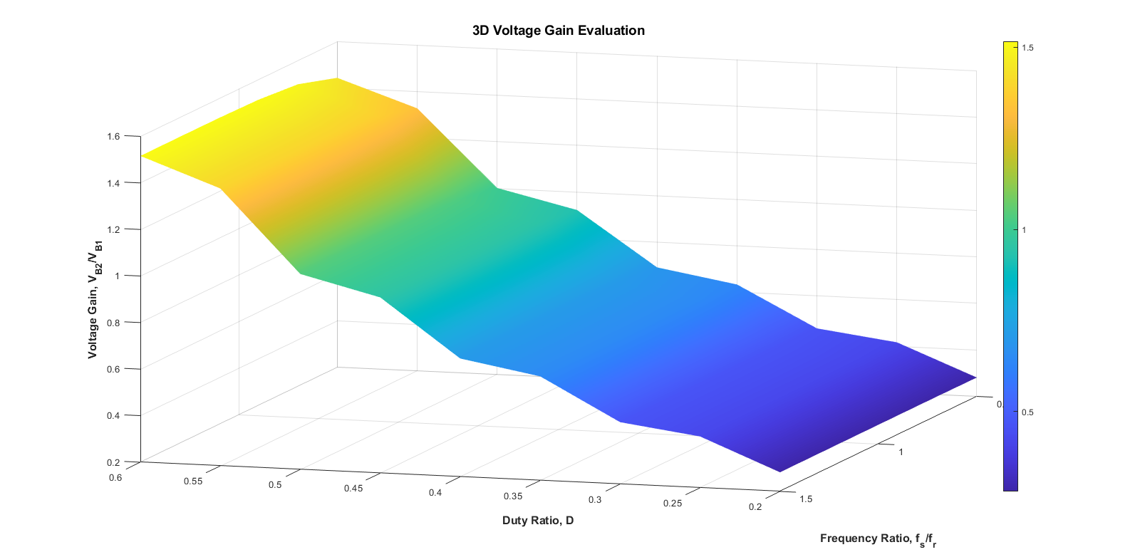
(a)
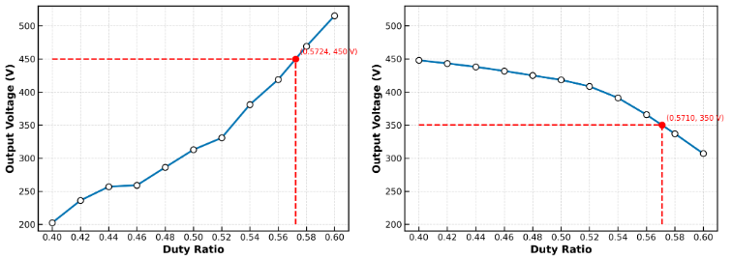
(b)
Fig. 4. Open-loop analysis: (a) voltage gain versus duty ratio and frequency ratio; (b) receiving-battery voltage versus duty ratio in Mode 1 (left) and Mode 2 (right).
B. Closed-Loop Transient Comparison
Each controller was tested in both modes with a constant current reference stepped from 10 A to 50 A in 10 A increments every 3 s. Fig. 5 compares the battery current and voltage of the three controllers during the start-up transient, and Table V lists the peak excursions and settling times extracted from these waveforms. PI produces the largest excursions, a 1567 A peak in I_{B2} and an 86 V dip in V_{B2}, and settles only after 71–74 ms (±2% band on the battery voltages). ISMC and FLC reduce the I_{B2} peak by about 62% and the V_{B2} dip by about 60%, and settle within 8.6 ms (V_{B2}) and 22 ms (V_{B1}), three to eight times faster than PI. The two nonlinear controllers behave almost identically in this transient; ISMC settles to a slightly larger I_{B1} offset (about 16 A against 4 A for FLC).

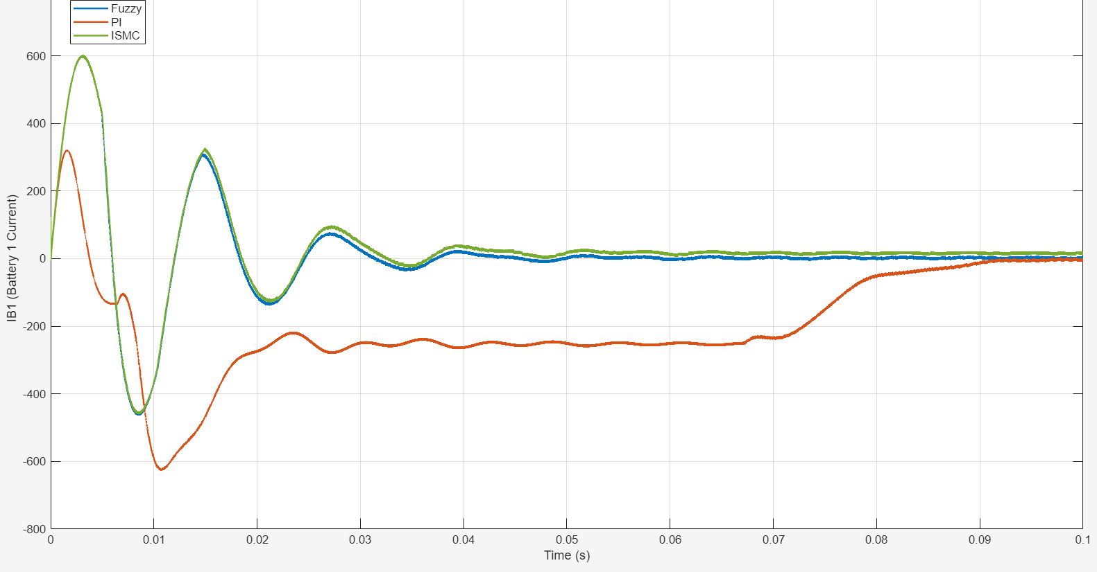
(a)
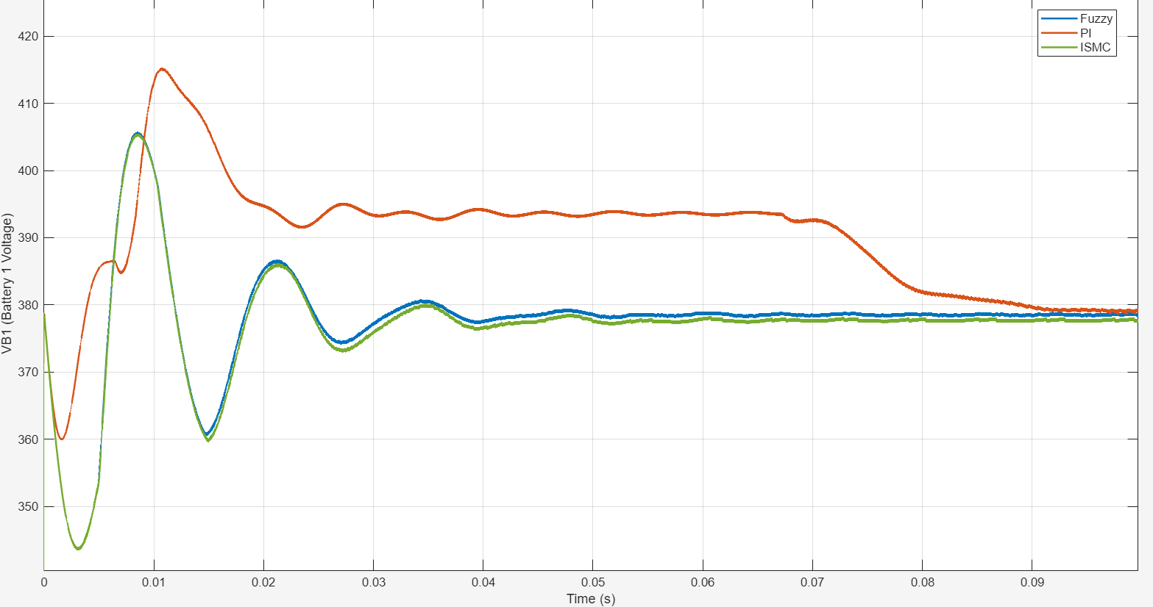
(b)
Fig. 5. Start-up transient of PI, ISMC and FLC in Mode 1: (a) battery current; (b) battery voltage.
TABLE V
TRANSIENT PERFORMANCE OF THE CONTROLLERS - MODE 1
Ctrl. | Peak |I_{B1}| (A) | Peak |I_{B2}| (A) | Max ΔV_{B2} (V) | t_{s}, V_{B1} (ms) | t_{s}, V_{B2} (ms) | t_{s}, I_{B2} (ms)*
PI | 625 | 1567 | 86.2 | 74.3 | 70.6 | 84.5
ISMC | 600 | 594 | 34.1 | 22.1 | 8.6 | 14.5
FLC | ≈600 | ≈594 | ≈34 | 21.8 | 8.6 | 14.2
*ts: settling time to ±2% of the final value for voltages and ±20 A for I_{B2}
C. Efficiency
Fig. 6 shows the efficiency for different source-battery SOCs with the receiving-battery SOC fixed at 25%. In Mode 1, PI gives the highest efficiency, 89–93%, while ISMC and FLC are lower or similar depending on SOC. In Mode 2, FLC is the most efficient at about 94–95%, ISMC is intermediate and PI is the lowest at 88–90%. The controller therefore affects not only the dynamics but also the switching pattern and hence the losses, and the best choice depends on the power-flow direction.
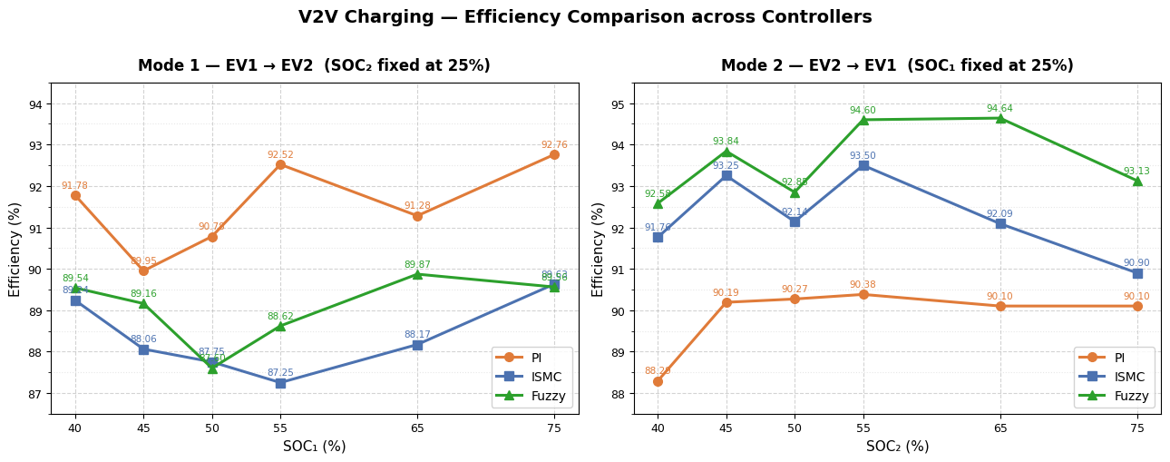
Fig. 6. Efficiency versus source-battery SOC (receiving-battery SOC fixed at 25%) for Mode 1 (left) and Mode 2 (right).
D. Semiconductor Losses
Conduction losses were computed from the V_{CE,sat}–I_{C} characteristic of the IGBT [15] as P_{cond} = V_{CE,sat}(I_{C})·I_{C}. Switching losses were obtained from the datasheet E_{on} and E_{off} curves, accumulated at each gate transition between 0.2 s and 1.5 s:
$P_{sw} = \frac{∑E_{on} + ∑E_{off}}{t_{end} − t_{start}}$ (10)
Table VI gives the computed totals for ISMC Mode 2: 272.2 W on the EV1 side and 266.1 W on the EV2 side, together about 2.2% of the rated power.
TABLE VI
ESTIMATED SEMICONDUCTOR LOSSES - ISMC MODE 2
Side | Conduction (W) | Switching (W) | Total (W)
EV1 | 124.96 | 147.23 | 272.19
EV2 | 140.95 | 125.19 | 266.13

E. Real-Time Software-in-the-Loop Validation
For real-time validation, the Simulink model was split into a computation subsystem containing the converter and batteries and a supervisory subsystem, exchanging eleven signals (voltage, current, power and SOC of each battery, and the input, feedback and reference signals). It was executed on an OPAL-RT OP4610XG with a 5 µs time step, and the analog outputs were captured on a mixed-signal oscilloscope [Fig. 7(a)]. Figs. 7(b)–(d) show Mode 1 operation with the three controllers: the measured quantities change in steps with the reference and the source-battery SOC decreases steadily, matching the offline results. Mode 2 shows the same behaviour with reversed power flow. Because the converter itself is simulated, these are SIL results; hardware-in-the-loop testing is left for future work.
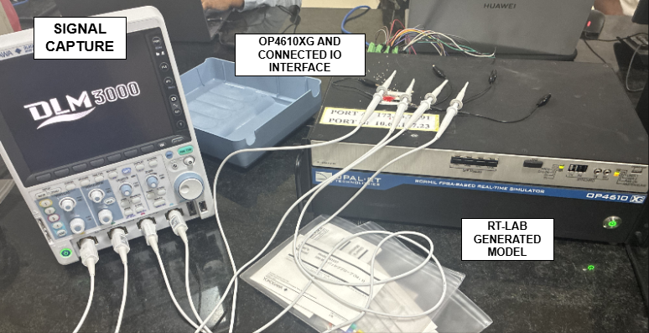  (a) | 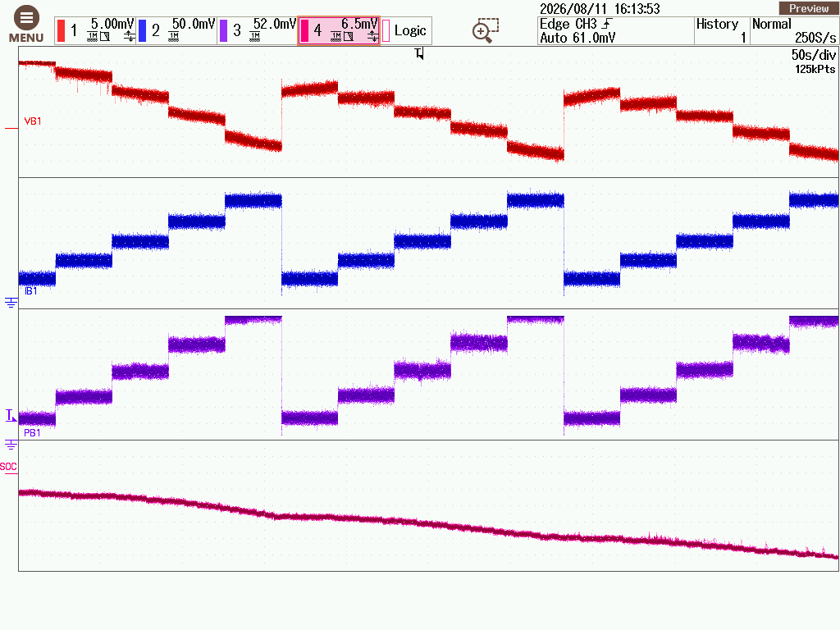  (b)
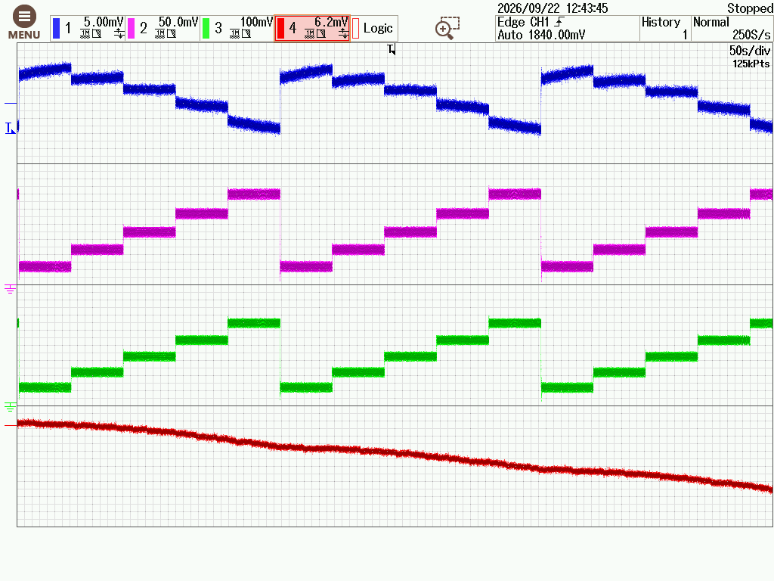  (c) | 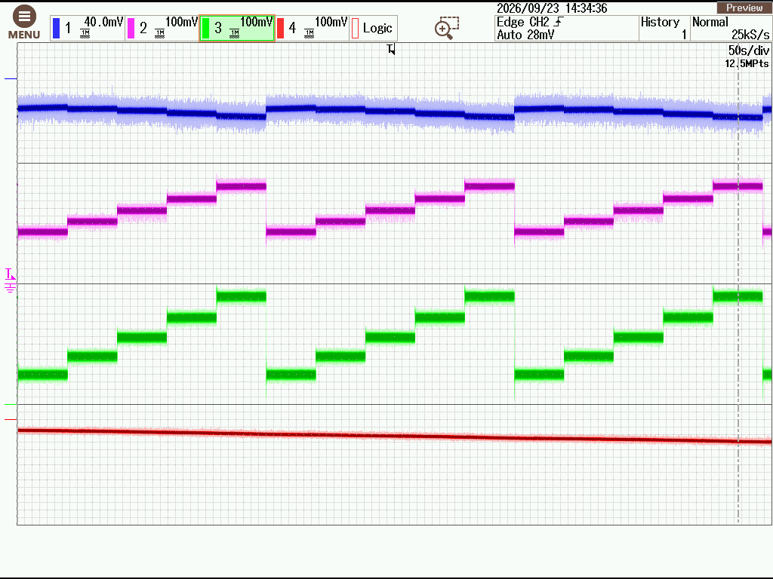  (d)
Fig. 7. OPAL-RT SIL validation: (a) OP4610XG setup with oscilloscope; Mode 1 waveforms with (b) PI, (c) ISMC and (d) FLC control.
VI. Conclusion
This paper evaluated PI, integral sliding-mode and fuzzy logic current control of an isolated single-stage bidirectional V2V converter that reuses the OBC bridges of both vehicles. Open-loop analysis identified operating duty ratios of 0.5724 and 0.5710 for EV1-to-EV2 and EV2-to-EV1 transfer between 350 V and 450 V batteries. In closed loop, ISMC and FLC settled faster and with smaller deviation than PI. FLC gave the highest efficiency, about 94–95%, for EV2-to-EV1 transfer, while PI was the most efficient (89–93%) for EV1-to-EV2 transfer, so the preferred controller depends on the power-flow direction. The estimated semiconductor loss was about 2.2% of rated power, and real-time SIL validation on OPAL-RT confirmed bidirectional operation with all three controllers. Future work will address hardware-in-the-loop testing, a Si versus SiC device comparison and a hardware prototype.
Acknowledgment
The authors thank the School of Electrical Engineering, Vellore Institute of Technology, Chennai, for providing the OPAL-RT real-time simulation facility.
References
[1] M. Haghani, F. Sprei, K. Kazemzadeh, Z. Shahhoseini, and J. Aghaei, “Trends in electric vehicles research,” Transp. Res. Part D: Transp. Environ., vol. 123, Art. no. 103881, 2023.
[2] M. Yilmaz and P. T. Krein, “Review of battery charger topologies, charging power levels, and infrastructure for plug-in electric and hybrid vehicles,” IEEE Trans. Power Electron., vol. 28, no. 5, pp. 2151–2169, 2013.
[3] A. Shafiqurrahman, B. S. Umesh, N. Al Sayari, and V. Khadkikar, “Electric vehicle-to-vehicle energy transfer using on-board converters,” IEEE Trans. Transp. Electrific., vol. 9, no. 1, pp. 1263–1272, 2023.
[4] S. Taghizadeh, M. J. Hossain, N. Poursafar, J. Lu, and G. Konstantinou, “A multifunctional single-phase EV on-board charger with a new V2V charging assistance capability,” IEEE Access, vol. 8, pp. 116812–116823, 2020.
[5] E. Ucer et al., “Analysis, design, and comparison of V2V chargers for flexible grid integration,” IEEE Trans. Ind. Appl., vol. 57, no. 4, pp. 4143–4154, 2021.
[6] V. T. Tran, M. R. Islam, K. M. Muttaqi, O. Farrok, M. R. Kiran, and D. Sutanto, “A novel universal magnetic power plug to facilitate V2V/V2G/G2V/V2H connectivity for future grid infrastructure,” IEEE Trans. Ind. Appl., vol. 58, no. 1, pp. 951–961, 2022.
[7] V. Shah and S. Payami, “Integrated converter with G2V, V2G, and DC/V2V charging capabilities for switched reluctance motor drive-train based EV application,” IEEE Trans. Ind. Appl., vol. 59, no. 3, pp. 3837–3850, 2023.
[8] H. Fan and H. Li, “High-frequency transformer isolated bidirectional DC–DC converter modules with high efficiency over wide load range for 20 kVA solid state transformer,” IEEE Trans. Power Electron., vol. 26, no. 12, pp. 3599–3608, 2011.
[9] V. Veerakgoundar and S. Subramaniam, “An efficient and compact voltage feed-forward DAB-based bidirectional DC–DC converter for onboard EV charger,” Comput. Electr. Eng., vol. 122, Art. no. 109979, 2025, doi: 10.1016/j.compeleceng.2024.109979.
[10] S. Deshmukh (Gore) et al., “Review on classification of resonant converters for electric vehicle application,” Energy Rep., vol. 8, pp. 1091–1113, 2022, doi: 10.1016/j.egyr.2021.12.013.
[11] R. Zhou, B. Chong, B. Labaleine, J. Arnett, and L. Zhang, “A novel isolated connector for bidirectional direct V2V charging using onboard chargers,” e-Prime – Nexus of Electrical, Electronic, and Intelligent Engineering, vol. 17, Art. no. 201193, 2026, doi: 10.1016/j.eprime.2026.201193.
[12] J. Sun, L. Qiu, X. Liu, and Y. Fang, “Adaptive integral sliding mode control based radial basis function network for bidirectional isolated dual active bridge converter,” in Proc. 23rd Int. Conf. Electr. Mach. Syst. (ICEMS), 2020, pp. 1312–1316, doi: 10.23919/ICEMS50442.2020.9291235.
[13] R. Shivakumar, A. Dhivya, and K. Rathnakannan, “Comparison of fuzzy logic and PI controlled dual active bridge bidirectional converter for electrical vehicle applications,” in Power Engineering and Intelligent Systems (PEIS 2025), Lecture Notes in Electrical Engineering, vol. 1459. Singapore: Springer, 2026, pp. 441–452, doi: 10.1007/978-981- 96-9716-8_35.
[14] S. Chitra Devi, A. Ramkumar, and K. Rajesh, “Optimized bidirectional power flow in hybrid systems using fuzzy logic and Fire Hawk search: An electric vehicle perspective,” Iran. J. Sci. Technol. Trans. Electr. Eng., 2025, doi: 10.1007/s40998-025-00859-6
[15] Infineon Technologies AG, “IKWH75N65EH7: High speed and low saturation voltage 650 V TRENCHSTOP IGBT7,” Datasheet, Nov. 2023. [Online]. Available: https://www.infineon.com/

